Austerity, economic growth, multipliers – and a radical solution to the banking and fiscal crises

by

David Hall

[d.j.hall@gre.ac.uk](mailto:d.j.hall@gre.ac.uk)

October 2012, revised March 2013

1. Introduction and summary 2

2. Austerity worsens recession – and government debt 2

Table 1. Austerity and GDP growth 2011-2012 3

Chart A. More austerity means economic contraction: 2008-2011 (Krugman) 3

Chart B. More austerity means economic contraction (IMF) 3

Chart C. Austerity makes government deficits worse 4

3. The wrong multipliers 5

3.1. Systematically overstated forecasts 5

3.2. Actual multipliers 5

Chart D. Austerity multiplier 2009-2011 (Krugman) 5

Chart E. Austerity multiplier 2008-2012 (Wolf) 6

3.3. The European Commission prefers theory 7

4. The IMF’s long-term evidence that its policies don’t work 8

4.1. The damaging effects of austerity 8

4.2. A long record of over-optimistic exaggeration of growth prospects 9

Chart F. Actual growth below IMF forecasts (UNCTAD 2011) 10

4.3. The negative effects of ‘good’ governance 11

5. Financial markets and ECB policy was the problem, not government borrowing 11

Chart G. Austerity measures and financial market borrowing ‘spreads’ in 2011 11

6. Re-nationalise money to avoid bank crises and eliminate state debt (says IMF) 12

# Introduction and summary

Austerity policies which prioritise rapid reductions in government deficits are being applied by many governments in Europe. They involve large cuts in public expenditure and some tax increases. The EU is a key driver of this process because of its targets for government deficits and debt, and because, along with the ECB and the IMF, it is part of the ‘troika’ which has insisted on particularly sharp austerity policies in Greece, Portugal, and Ireland, and placed great pressure on other countries such as Italy and Spain to do likewise.

This paper examines:

* the evidence of the impact of these policies on economic growth, which shows that, greater austerity leads to greater falls in GDP
* the failure of the forecasts used in austerity programmes, as a result of using economic multipliers – which estimate the economic impact of changes in government deficit – which have proved to be far smaller than the actual relationship visible
* the European Commission’s ‘Report on Public Finances in EMU 2012’ includes a theoretical simulation attempting to show that austerity should not damage the debt-to-GDP ratio, but does not address the actual empirical data nor the direct relationship between austerity and GDP
* the IMF itself has already published evidence based on long-term experience, showing that:
  + the impact of austerity on GDP was consistently underestimated by forecasts on earlier austerity programmes, which was already well known in 2009
  + the negative multiplier effects of austerity are even greater in recessions, and that “withdrawing fiscal stimuli too quickly in economies where output is already contracting can prolong their recessions without generating the expected fiscal saving. This is particularly true if the consolidation is centred around cuts to public expenditure…and if the size of the consolidation is large.”
  + another IMF study showed that the ‘good governance’ of reduced regulation – a key part of the Troika’s austerity programmes - is not simply of no benefit but a serious liability: countries which follow this recipe for economic liberalisation consistently performed *worse* in the economic crisis than other countries.
* The crises over government debts in the Eurozone were originated from panic in the financial markets, not from profligate governments or problems in the real economy
* the economic crisis originated from the banking sector, and a remarkable paper from the IMF shows that government spending and the renationalisation of money could be the long-term solution for avoiding future banking crises..

# Austerity worsens recession – and government debt

Before discussing multipliers, it is important to address the more fundamental question: what are the actual observable effects of austerity on economic performance as measured by GDP? The advocates of austerity programmes argue that they are a way of improving economic performance. Critics argue that they have the opposite effect of reinforcing recession and creating higher unemployment: in addition, this damage to the real economy makes government deficits worse because it reduces government revenues and increases the need to pay benefits.

The empirical evidence shows a clear picture. Since the financial crisis of 2008, there has been a clear correlation between the size of a reduction in government deficits and a change in GDP. The greater the reduction in fiscal deficit, the worse the contraction in the economy.

A recent graphic from LSE professor Paul de Grauwe shows the extremely close relationship since 2011: there is “a strong negative correlation” between austerity and growth.

1. Austerity and GDP growth 2011-2012

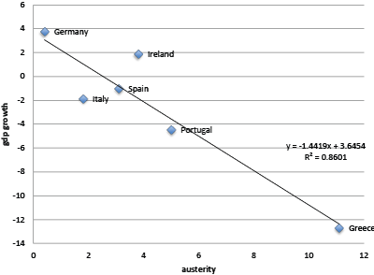

Source: [Panic-driven austerity in the Eurozone and its implications Paul De Grauwe, Yuemei Ji,](http://www.voxeu.org/article/panic-driven-austerity-eurozone-and-its-implications) 21 February 2013

This confirms the evidence which has been presented since 2008 by the Nobel-prize winning economist Paul Krugman in the New York Times: the greater the cuts in public spending, the greater the fall in GDP.

1. More austerity means economic contraction: 2008-2011 (Krugman)

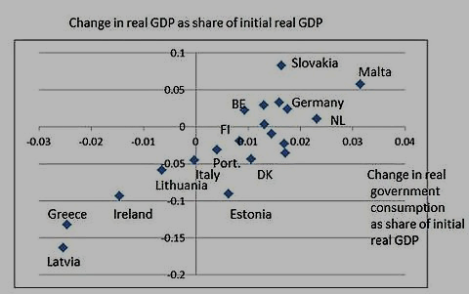

Source: [Austerity - Blunder of Blunders 23/03/2012](http://krugman.blogs.nytimes.com/2012/03/22/blunder-of-blunders/) by Paul Krugman

The IMF itself has presented similar evidence in relation to both high income countries and developing countries, as shown in the graphs below from its 2012 monitor of

1. More austerity means economic contraction (IMF)

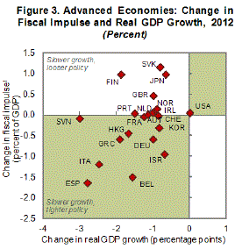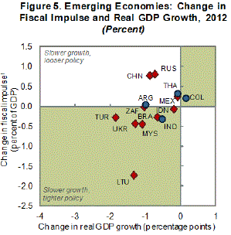

[IMF Fiscal Monitor Update January 2012](http://www.imf.org/external/pubs/ft/fm/2012/update/01/fmindex.htm)

Not only do austerity measures reduce GDP, they also worsen the level of government debt. This is because they shrink GDP faster than they shrink government deficits. The graph shows a very strong correlation – the worse the austerity measures, the higher the level of government debt as a % of GDP.

1. Austerity makes government deficits worse

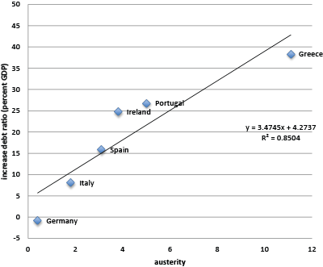

Source: [Panic-driven austerity in the Eurozone and its implications Paul De Grauwe, Yuemei Ji,](http://www.voxeu.org/article/panic-driven-austerity-eurozone-and-its-implications) 21 February 2013

# The wrong multipliers

## Systematically overstated forecasts

The austerity measures encouraged by the IMF and the European Commission since 2009, and imposed under Troika conditions and government policies in the EU, have been justified in terms of the short and long-term impact on economic growth. The policies are accompanied by forecasts of what will happen to economic growth as a result of the policies, and these forecasts are based on multipliers.

As the previous section made clear, the actual results of austerity have been to worsen the contraction of economies. This is contrary to the claims by the IMF, European Commission, OECD and governments that these austerity policies would improve the economy. It is therefore not surprising that the IMF, in the October 2012 World Economic Outlook, has found that the forecasts of economic growth following austerity have been systematically overstated by a large margin.

The WEO confirms that this applies to the forecasts of all the international institutions - the IMF, European Commission, and OECD – and one leading private forecaster, the Economist Intelligence Unit. It also confirms that the overstatements are not explicable by exceptional cases of high debt levels, or trade imbalances, or even the activities of financial markets. The WEO says bluntly that the relationship between forecasts and actual outcomes is “large, negative, and significant”. ([IMF WEO Oct 2012 Box 1.1 p.41](http://www.imf.org/external/pubs/ft/weo/2012/02/pdf/text.pdf)).

The multipliers used in forecasts by the IMF and others were around 0.5, according to the WEO (although the assumptions were so vague that this itself is only a rough estimate: “not

all forecasters make these assumptions explicit. Nevertheless, a number of policy documents, including IMF staff reports, suggest that fiscal multipliers used in the forecasting process are about 0.5”).

The WEO now estimates that the actual multipliers have been between 0.9 and 1.7. ([IMF WEO Oct 2012 Box 1.1 p.43](http://www.imf.org/external/pubs/ft/weo/2012/02/pdf/text.pdf)) The gap between reality and forecast is thus extremely large. The negative effects on economic growth have been three times as great as forecast by the IMF, EU or OECD.

## Actual multipliers

The WEO estimate of actual multipliers between 0.9 and 1.7 is consistent with other estimates. For example, in April 2012 Krugman estimated the actual multiplier effect of austerity in Europe as 1.25. He further notes that: “this also implies that 1 euro of austerity yields only about 0.4 euros of reduced deficit, even in the short run.” Martin Wolf, at the same time, estimated that the actual multiplier has been 1.5: “Every percentage point of structural fiscal tightening is estimated to lower GDP by 1.5 per cent of its 2008 level. So the 8 percentage points of structural fiscal tightening in Greece lowered its GDP by 12 per cent.”

However, this general multiplier conceals a significant difference between cuts in spending and increases in taxation: the multiplier effect of cuts in spending is much greater. An IMF research paper (below) estimates a range of 1.6 to 2.6 for spending cuts, compared with a multiplier of only 0.16 to 0.35 for tax increases ([IMF WP12190 p.7](http://www.imf.org/external/pubs/ft/wp/2012/wp12190.pdf) )

1. Austerity multiplier 2009-2011 (Krugman)

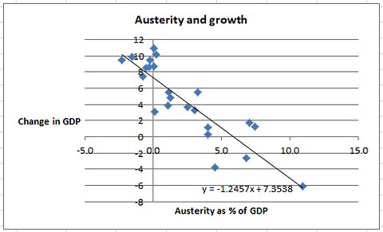

<http://krugman.blogs.nytimes.com/2012/04/24/austerity-and-growth-again-wonkish/>

1. Austerity multiplier 2008-2012 (Wolf)

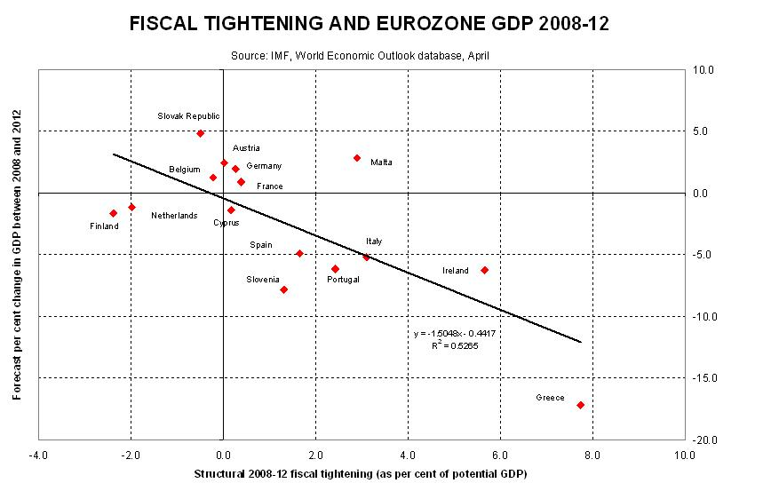

<http://blogs.ft.com/martin-wolf-exchange/2012/04/27/the-impact-of-fiscal-austerity-in-the-eurozone/#axzz1sy4qGXP8>

## The European Commission prefers theory

The recent European Commission report on public finances attempts a tortuous defence of the possibility of austerity policies being compatible with growth in GDP. (Report on Public Finances in EMU 2012, European economy series 4/2012 p.113 <http://ec.europa.eu/economy_finance/publications/european_economy/2012/pdf/ee-2012-4.pdf> )

Unlike the WEO, it does not ask the empirical question of what the multipliers have been, nor does it ask whether the European Commission’s forecasts and assumptions have been wrong. It is therefore fortunate that the WEO analysis covers the EU (and OECD) forecasts, as well as the IMF’s, in its demonstration of how incorrect the assumptions have been. We can therefore be confident that the European Commission’s forecasts have been as badly exaggerated as the others.

Instead of addressing the empirical data, the European Commission paper prefers to try and reject the critique that “austerity can be self-defeating… [because] a reduction in government expenditure leads to such a strong fall in activity that fiscal performance indicators actually get worse”. The evidence shows this is actually happening, on a very damaging scale, as set out above, but the paper prefers to describe this as “counter-intuitive dynamics”: in other words, it runs counter to their beliefs. It can then treat it as an unwelcome theoretical possibility, rather than a brutal reality. The paper then states that it will “define precisely the conditions under which counter-intuitive dynamics can happen” - by contrast, again, with the empirical approach of the WEO paper, which demonstrates quite simply that they have indeed happened, on a large scale, in the conditions of the last two years.

It presents a lengthy and thorough review of the literature, covering much of the same ground as was covered in the IMF paper in 2009, which shows that economists have a a wide range of different theories, methodologies and estimates of multipliers. It homes in on a range of 0.7-1.2 in the current climate, which is significantly less than the WEO and other estimates based on actual empirical data (see above).

It then conducts an elaborate simulated model of what multipliers might be, and what the effects of austerity on the debt-to-GDP ratio might be.

Two points are worth emphasising about this exercise.

Firstly, unlike the WEO, it does not address the empirical question of what the multiplier effects have actually been over the last three years. This is entirely a theoretical exercise.

Secondly, at no point does the paper discuss directly the effects of austerity on economic growth or unemployment. The entire exercise is focussed only on whether the GDP-debt ratio might be worsened as a result of the multiplier effects. Thus the editorial for the entire issue says “concerns have been raised that further fiscal consolidation amid weak growth prospects may have self-defeating effects on debt ratios.” The impact on growth or unemployment in themselves, which is the principal concern of most critics, is treated as of no interest except as a mechanism influencing the debt ratio.

The conclusions show an agonised awareness of reality lurking in the background, but a clear position that if so, the fault lies firmly with reality. It concedes that actual multipliers may differ from the estimates:

“the risks of such [counter-intuitive] effect to arise from consolidation in the present context are overstated under plausible assumptions, although over the short-term increases in the debt-to-GDP ratio may be observed, driven by the denominator effect. Such debt increases are in most cases short-lived and followed by a fall in the debt ratio below the baseline of unchanged policy. In other words, over the medium-term, consolidations are generally successful in reducing the debt-to-GDP-ratio.” (p.159)

It attempts to protect its simulation by acknowledging that:

“the presence or absence of counter-intuitive effects from consolidations on debt dynamics is primarily driven by the size of the GDP multiplier. …. The range was based on the existing economic literature; however it is likely that one-year multipliers are larger in the current crisis period than in normal times.”

In a final remarkable paragraph it presents a tortuous claim that its model also allows for an extremely unlikely, but theoretically possible, set of circumstances in which things might just go wrong.

“It is however shown that for high but plausible values of the multipliers, such counter-intuitive effects are short-lived unless the multipliers have a high persistence – which can happen only in cases where the fiscal adjustments are repeatedly noncredible– or if effects on interest rates are high and contrary to what is normally expected in consolidations. A fully self-defeating dynamic would only be generated under very unlikely configurations, i.e. situations in which multipliers are very large and interest rates rise significantly (and counter-intuitively) due to the consolidation and debt developments. A high degree of financial market myopia is also required for these effects to exist.” (p.160)

This is quite close to reality, which may explain why the authors repeatedly attempt to describe it as implausible, counter-intuitive, short-lived, non-credible, abnormal, self-defeating, unlikely and myopic. Anything rather than evidence-based policy-making.

# The IMF’s long-term evidence that its policies don’t work

The experience with austerity in the Eurozone is not a surprising new development. The IMF knows that long-term evidence shows that its standard policies of austerity coupled with privatisation and liberalisation not only do not work, but actually damage economies. It has published three recent reports which set out this evidence in some detail.

## The damaging effects of austerity

The damaging effects of austerity on growth were explicitly spelt out in an IMF research paper on the long-term evidence on the effects of austerity, published in August 2012 ([IMF WP12190 p.7](http://www.imf.org/external/pubs/ft/wp/2012/wp12190.pdf) ). The paper was given the extremely misleading title of “Successful Austerity in the United States, Europe and Japan”: however, its main conclusions did not identify any successes, but rather confirmed that damage to growth is extremely likely, especially in recession:

* The multiplier effects “are significantly larger in downturns than in upturns”, so recession is the worst time to implement any form of fiscal consolidation
* Fiscal consolidation is twice as likely to deepen a downturn if it is made in a recession, more likely to have a recessionary effect if it is concentrated upfront,
* The benefits of ‘confidence effects’ “do not seem to have ever been strong enough to make the consolidations expansionary”, so the supposed trade-off of restoring market confidence never compensates for the damage
* The multiplier effect of spending cuts is much greater than that of tax increases, so consolidation through spending cuts is the most harmful
* “frontloading fiscal consolidations tends to have harsher and more protracted adverse effects on output”
* And most generally, as stated in the concluding remarks: “withdrawing fiscal stimuli too quickly in economies where output is already contracting can prolong their recessions without generating the expected fiscal saving. This is particularly true if the consolidation is centred around cuts to public expenditure…and if the size of the consolidation is large.”

As an analysis by Ronald Janssen concluded, this paper: “is simply devastating for traditional and mainstream recommendations on fiscal policy and austerity.” (<http://www.social-europe.eu/2012/10/blame-it-on-the-multiplier/> )

## A long record of over-optimistic exaggeration of growth prospects

Much of the discussion of the IMF new position has referred to the multipliers used in the forecasts as ‘errors’. However, if was simply an error, one would expect there to be an equal chance of overstatement and understatement, but the unreliability is all in one direction. Was it reasonable for the IMF (and the EU, and the OECD) to make such a big error in this direction?

The IMF published a discussion paper on multipliers in 2009 ( IMF 2009 Fiscal multipliers <http://www.imf.org/external/pubs/ft/spn/2009/spn0911.pdf> ). It presented a number of examples of multipliers and offered some generalisations:

“The size of the fiscal multiplier is country-, time-, and circumstance-specific…..The profession disagrees on the reliability of the multipliers, partly because of methodological differences, and partly because the range of estimates, even for similar methodologies, is often quite large.” (p.3)

This assessment of the uncertainty of multipliers should have led the IMF (and the EU and OECD) to be extremely cautious about insisting on an austerity policy where the impact on growth depended on such an uncertain variable.

The IMF had also known for some years that its growth forecasts for austerity packages were systematically over-optimistic. A detailed examination of fiscal adjustment in 133 IMF-supported programmes in 70 countries carried out by the IMF’s own Independent Evaluation Office (IEO) in 2003 noted:

“There is a tendency to adopt fiscal targets based on overoptimistic assumptions about the pace of economic recovery leading inevitably to fiscal underperformance and frequent revisions of targets. The optimism about growth recovery in the short term is itself often the consequence of overoptimistic assumptions about the pace of revival of private investment when a more realistic assessment in certain circumstances could have justified the adoption of a more relaxed fiscal stance on contracyclical grounds…. Optimism regarding growth recovery was particularly significant in programs that started from an adverse situation. When growth was negative during the first year of the program, growth projections for the second year were on average twice as high as in reality. Moreover, programs were generally reluctant to project a slowdown in growth and very rarely projected negative growth. For example, growth slowdowns between the first and second year of the program occurred twice as often as they were projected. Negative growth for the second year of the program was projected in only 1.3 percent of cases, but in reality it happened 10 times as frequently.” (IMF 2003 Fiscal Adjustment in IMF-Supported Programs [www.ieo-imf.org/ieo/files/completedevaluations/09092003main.pdf](http://www.ieo-imf.org/ieo/files/completedevaluations/09092003main.pdf))

A 2011 report by UNCTAD (UNCTAD Trade and development report, 2011 “Post-crisis policy challenges in the world economy” <http://unctad.org/en/Docs/tdr2011_en.pdf> ) presented a similar damning analysis of IMF austerity programmes. It found that in nearly all cases, the outturns in terms of GDP growth were worse than the IMF forecasts:

“outcomes systematically failed to live up to expectations. In some cases, the gaps are sizeable: in 1998, a GDP growth of 5 per cent was forecast for Indonesia, but in fact it experienced minus 13 per cent growth; Thailand was expected to achieve 3.5 per cent growth, but growth actually contracted by 10.5 per cent; and the Republic of Korea was expected to achieve 2.5 per cent growth but it actually recorded minus 5.7 per cent. In recent years, growth outcomes have been overestimated by more than 5 percentage points in Georgia, Hungary, Latvia, Serbia and Ukraine.”

1. Actual growth below IMF forecasts (UNCTAD 2011)



<http://unctad.org/en/Docs/tdr2011_en.pdf>

The UNCTAD report also pointed to the remarkable absence of an explanation as to how fiscal tightening was supposed to translate into economic growth:

“Misjudging the effects of fiscal tightening seems to be the rule rather than the exception in IMF-backed programmes…. In country after country where fiscal tightening was expected to both reduce the budget deficit and boost investment and economic growth, the opposite happened. Private sector demand and investment, in particular, responded much more sluggishly than the IMF had expected. In addition, fiscal balances, on average, failed to improve during the first two years of the fiscal adjustment programmes, even though this was an explicit goal of those programmes. The main reason for the shortfalls in countries that made large fiscal adjustments was that government revenues fell far below expectations. On the other hand, the spending cuts were on target. This record of failed IMF-sponsored adjustment programmes suggests that they are based on a fundamental macroeconomic misconception. The conceptual basis is not quite clear. The majority of programmes reviewed by the IMF-IEO did not explain the links between the targeted fiscal adjustment and the envisaged improvement in the external situation, or the assumptions driving the projected recovery of private spending and how it was linked to the fiscal policies recommended.” (p.65)

## The negative effects of ‘good’ governance

The systematically unreliable growth forecasts are not the only problem of austerity programmes. These programmes also include ‘improvements’ in economic governance, including less regulation of private business activity.

But research by both the IMF and the ECB has demonstrated that these very policies have in fact been highly damaging.

An IMF paper (The Economic Crisis: Did Financial Supervision Matter? WP 11/261 <http://www.imf.org/external/pubs/ft/wp/2011/wp11261.pdf> ) found that countries which scored best on market-friendly regulation, as defined by the World Bank indicators of ‘good governance’, did worst in the recession:

“the countries with the best ratings in terms of public sector regulatory framework, as well as those countries with the most far reaching financial deregulation, were hit the hardest economically”.

‘Good’ regulation was not just useless, it was damaging: “This variable is negative and highly significant…”. So the World Bank governance index is still useful- the worse you score, the better your economic prospects.

The same was true of countries which had liberalised the banking sector: “the significantly negative coefficients indicate that the countries that liberalized their financial systems the most, were most affected by the banking and economic crisis.”

Similar results had already been published by the OECD in a paper co-authored by an ECB economist and others , which also found that countries did better on economic growth, and less badly in the crisis, if they scored badly on ‘market friendliness’ – especially in the financial sector. (Market freedom and the global recession 2010 <http://www.oecd.org/economy/productivityandlongtermgrowth/46418753.pdf> )

It also confirmed [research](http://www.sciencedirect.com/science/article/pii/0304387885900367) carried out in Latin America in the 1980s, which showed that financial liberalisation damages growth.

# Financial markets and ECB policy was the problem, not government borrowing

The policy of austerity is also based on a false diagnosis of the problem. Austerity assumes that the problems of financing government debt rae due to irresponsible behaviour by governments themselves, and/or underlying weaknesses in the econoy.

But De Grauwe and his colleague set out evidence which confrirms the “strong perception that countries that introduced austerity programs in the Eurozone were somehow forced to do so by the financial markets”. There is an almost perfect correlation between the interest demanded by the markets for debt of different countries, and the degree of austerity they adopted.

They also found that the spreads dropped as soon as the ECB offered support in 2012 – as it could have done from the start in 2009.

1. Austerity measures and financial market borrowing ‘spreads’ in 2011

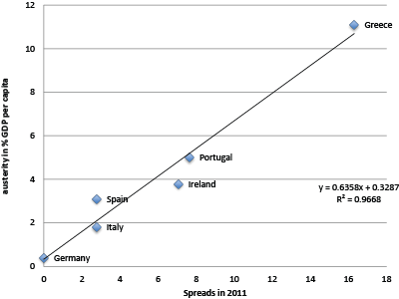

Source: [Panic-driven austerity in the Eurozone and its implications Paul De Grauwe, Yuemei Ji,](http://www.voxeu.org/article/panic-driven-austerity-eurozone-and-its-implications) 21 February 2013

# Re-nationalise money to avoid bank crises and eliminate state debt (says IMF)

The IMF has also published an improbable proposal to avoid future banking crises, which would at the same time effectively eliminate government debt. The proposal is a re-launch of a plan from the 1930s, known as the Chicago Plan, under which banks would no longer be allowed, as they are now, to print money by lending far more than the savings deposited with them. Instead, banks would have to provide 100% backing of deposits with money issued by governments. The right to create money would be renationalised.

The expected benefits are huge. It would automatically give depositors security, prevent banks from issuing too much credit, allow governments to raise money without getting into debt, and so avoid government debt and interest payments, and reduce private debt as well.

The authors, senior economists at the IMF, tested the plan on their standard economic model and concluded that all of these benefits would result from such a plan – and, in addition, there would be a 10% increase in GDP:

“Our analytical and simulation results fully validate Fisher’s (1936) claims. The Chicago Plan could significantly reduce business cycle volatility caused by rapid changes in banks’attitudes towards credit risk, it would eliminate bank runs, and it would lead to an instantaneous and large reduction in the levels of both government and private debt….One additional advantage is large steady state output gains ….. Another advantage is the ability to drive steady state inflation to zero…[which] answers the somewhat confused claim of opponents of an exclusive government monopoly on money issuance, namely that such a monetary system would be highly inflationary.”

(Jaromir Benes and Michael Kumhof 2012 The Chicago Plan Revisited IMF Working Paper WP/12/202 August 2012 <http://www.imf.org/external/pubs/ft/wp/2012/wp12202.pdf> )

This remarkable paper has generated some enthusiastic support in principle, for example from Martin Wolf, the chief economist of the Financial Times. Criticising the way that some governments have used ‘quantitative easing’ to allow the private sector to print money, he wrote:

“it is impossible to justify the conventional view that fiat money should operate almost exclusively via today’s system of private borrowing and lending. Why should state-created currency be predominantly employed to back the money created by banks as a byproduct of often irresponsible lending? Why is it good to support the leveraging of private property, but not the supply of public infrastructure?”

(Martin Wolf FT 12 Feb 2013 The Case for Helicopter Money <http://www.ft.com/cms/s/0/9bcf0eea-6f98-11e2-b906-00144feab49a.html#axzz2OByj2aJK> )

Wolf is also scathing about the way banks succeed in gaining such privileges:

“Banks are not special, except for what they are allowed to get away with. …The problem is bigger than that banks are “too big” or “too interconnected” to fail. It is that they are so complex and so grossly undercapitalised. The model is intellectually bankrupt. The reason that this is not more widely accepted is that bankers are so influential and the economics are so widely misunderstood.”

Martin Wolf FT 17 March 2013 Why bankers are intellectually naked. [http://www.ft.com/cms/s/2/39c38b74-715d-11e2-9b5c-00144feab49a.html - axzz2OByj2aJK](http://www.ft.com/cms/s/2/39c38b74-715d-11e2-9b5c-00144feab49a.html#axzz2OByj2aJK)

And so it emerges that the banks are the problem, and government spending is the solution – not just for dealing with short-term crises but as a sustainable long-term economic model.