Self-assessment or public debate?

-evaluating the liberalisation of network services in the EU and USA

by

David Hall
d.j.hall@gre.ac.uk
Director, Public Services International Research Unit

September 2007



A report commissioned by the European Federation of Public Service Unions (EPSU) www.epsu.org
1. Introduction 2
2. The missing public debates in Europe 2
3. Decisions and debates on electricity liberalisation in the USA 3
4. The impact on prices: evidence from the USA 5
5. Economic impact: productivity, employment, growth and cohesion 8
6. Conclusions 10
7. Notes 12

Introduction
The European Union’s policies towards public services continue to be based around the drive to expand the internal market. One aspect of this is the set of Directives which require member states to liberalise the structure of the ‘network’ public services – electricity, gas, post, telecoms, rail, air, and urban transport. These sectors are of great economic and social importance, accounting for 7.5% of the whole output of the EU, employing 10.5 million people - over 5% of the EU workforce, and providing vital services for the entire population.

The European Commission (EC) maintains that liberalisation in these sectors brings consumer choice and competition, and as a result lower prices and improvements in efficiency, which benefit both industry and consumers. It produces its own annual report evaluating these policies, and is satisfied that these reports justify the continuation of existing policies and indeed further extension of liberalisation.

This paper discusses three main issues:

- the lack of public debate in Europe, compared with vigorous debate and policy revision in the USA
- comparative evidence from the USA on the effects of liberalisation on prices
- the uncertain economic effects of liberalisation compared with the benefits of public investment through the cohesion funds

Finally, it discusses the criteria that could be used in reviewing and revising European public policies in these services.

The missing public debates in Europe
Liberalisation of the electricity, gas, telecoms, post, rail, air and urban transport services is required by legislation at EU level. One consequence is that, for the first time in history, there are no differences between the systems of provision of electricity and gas services in countries of the European Union.

In the former communist countries of eastern Europe, a single system of central state ownership and operation was centrally imposed until the ending of the communist regimes around 1990. The Nordic countries created a single electricity market in the early 1990s, under a mixture of state, municipal and private ownership. Up to 1998, other EU countries used various mixtures of state, municipal and private ownership, mainly but not exclusively with vertical integrated companies, developing trade in electricity on an adhoc basis, e.g. creating and using the UK-France interconnector.

This diversity ended in 1998, when the first electricity and gas directives imposed a single standard form of sectoral organisation on all member states. This uniform, EU-wide legislation prohibits the use of vertically integrated monopolies, whether publicly owned or regulated, and requires all EU member states to operate a wholesale and retail market in electricity. The former public policy debates on the merits of different systems can no longer be held at national level, because a change of policy in any of the 27 member states would require a decision at EU level.

There is an annual evaluation of these sectors, conducted by the European Commission, which should at least provide an opportunity for a public policy debate. The European Parliament in October 2001 specified that public debate should form part of the process, requested greater public participation and proposed to “organise the debate within the various existing forums (Economic and Social Committee, Committee of the Regions, consultative bodies, associations involved in services of general interest initiatives and consumer associations)”. In 2002 the Commission promised that the evaluations would include “a permanent mechanism for the monitoring of citizens’ opinion and their evolution” , the consultation of stakeholders, including the social partners, and a great expansion of public participation .

But the EC has never conducted these evaluations through a public and democratic framework, and has simply published an annual evaluation as a technical report - the document is not addressed to any of the EU’s democratic institutions, but simply designated as a ‘Commission Staff working document’. No actors outside the Commission are involved in the production of the reports; no process is created for assessment of the issues through the democratic institutions of the EU and its member states; and the reports are published only in English, indicating that widespread debate was neither expected nor desired. The only element of public discussion has been two meetings with the European Economic and Social Committee, which took place after the evaluations of 2005 and 2006 were published.

Nor do these papers acknowledge the possibility of policies being reviewed in the light of evidence. The reports set out the set of beliefs behind liberalisation, including the expectation that competition will allow consumer choices and that this will drive down prices and increase efficiency. But none of the reports have ever indicated that liberalisation policies might be changed if the evidence showed this was not happening.

In Europe, the control of policy by the EC, and the absence of public debate at national level, has been crucial in keeping the EU moving in the opposite direction to the global trend, according to Jamash and Pollitt, writing about the electricity sector :

“Against this background of a world-wide slow-down in the pace of electricity reform, the centrally driven effort by the European Commission has been the main force that keeping the program on course. ….. Given the strategic position of the electricity industry in national politics, in the absence of policy at the level of the European Union (EU), the pace of reform in many member states would have been considerably slower.”

By contrast, in countries outside the EU, there are vigorous public debates on these issues, and an active process of policy decisions to change liberalisation or regulation. The actual experiences with liberalisation in the electricity sector, in particular, have led to vigorous public debates and policy changes. The next section examines this process in the USA where the emerging trend is to reverse, halt, or slow down the process of liberalisation – in sharp contrast to the European Commission’s insistence that the solution to any problem must involve an acceleration of market opening.

Decisions and debates on electricity liberalisation in the USA
Although the USA is a single country, unlike the EU which is a federation of independent countries, the individual states of the USA have greater freedom to decide how to organise their electricity services than the member states of the EU.

In the 1990s the USA federal government legislated to give independent generating companies access to transmission grids, without being subject to regulation by the states. The states however remained free to decide whether to unbundle public utilities, fully liberalise wholesale markets and introduce retail competition. These liberalisation policies are known in the USA as ‘deregulation’, because they involve ending the previous system of regulated monopoly utilities. At the end of 1990s, about half of the states had planned to introduced retail competition, but the California crisis of 2000, when blackouts and huge price rises resulted from the introduction of a wholesale electricity market, halted this trend, and a number of states reversed their previous policy of moving towards de-regulation. Half of all the states in the USA have never considered introducing retail competition – a policy which is compulsory for member states in the EU.

USA: States decisions on retail competition in electricity
Full retail competition | 17 | Connecticut, D.C., Delaware, Illinois, Massachusetts, Maryland, Maine, Montana, New Hampshire, New Jersey, New York, Ohio, Pennsylvania, Rhode Island, Texas, Virginia | 16
Retail competition for large consumers only | 2 | Nevada, Oregon | 2
Restructuring legislation delayed or repealed | 6 | Arizona, Arkansas, California, New Mexico, Oklahoma, West Virginia | 6
Not considering deregulation | 26 | Alabama, Alaska, Colorado, Florida, Georgia, Hawaii, Idaho, Indiana, Iowa,Kansas, Kentucky, Louisiana, Minnesota, Mississippi, Missouri, Nebraska, North Carolina, North Dakota, South Carolina, South Dakota, Tennessee, Utah, Vermont, Washington, Wisconsin, Wyoming | 26
APPA: Power Supply Procurement in Retail Choice States June 2007

Variation in state policies on retail competition
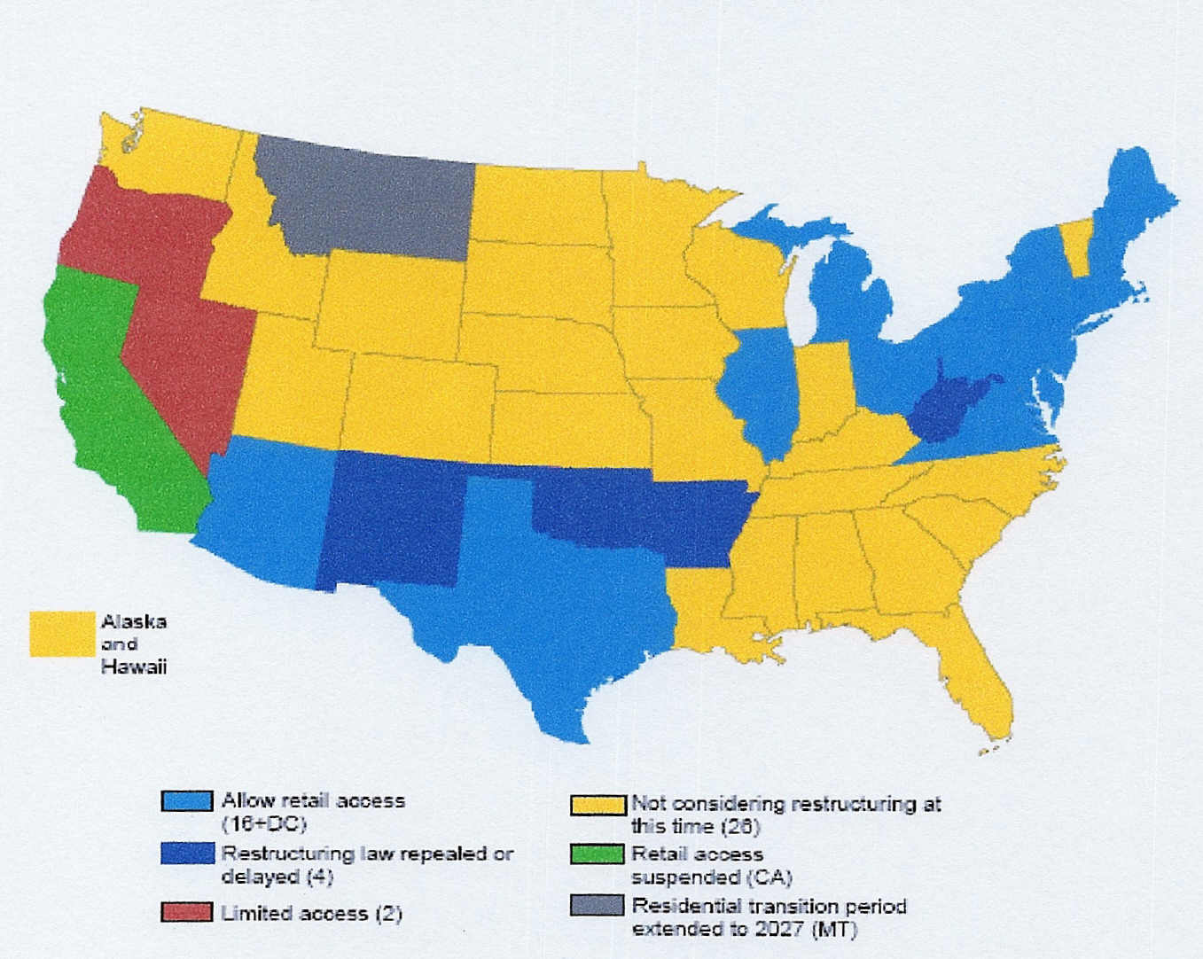

Source: Rose, Kenneth and Karl Meeusen, 2006 Performance Review of Electric Power Markets: Review
Conducted for the Virginia State Corporation Commission, August 27, 2006
http://www.scc.virginia.gov/caseinfo/reports/2006_rose_1.pdf;

Most significantly, the actual experience with deregulation has been so bad that those states which deregulated are now seeking ways to reverse their decision. The New York Times summarised the trend in September 2007 :

“More than a decade after the drive began to convert electricity from a regulated industry into a competitive one, many states are rolling back their initiatives. …. The main reason behind the effort to return to a more regulated market is price. Recent Energy Department data shows that the cost of power in states that embraced competition has risen faster than in states that had retained traditional rate regulation.”

The pattern of developments in the state of Delaware is typical. Retail competition and vertical unbundling were introduced in 1999, with a transitional arrangement for the state utility to continue providing a service of last resort while consumers transferred to competing suppliers offering lower prices. By 2006, no competitive market had emerged, and the vast majority of customers remained with the utility, which was now forced to raise prices to cover the cost of power purchased from the companies owning the generators. New legislation was passed to protect the consumer and re-assert that “the generation, supply and sale of electricity…. shall be treated as a public utility service or function”. The state of Delaware then hired an independent consultant to study the implications of re-regulation. The report, in May 2007, argued that there were no longer simple obvious technically best solutions, but a need for new democratic institutional mechanisms:
“It is no longer clear who is responsible for anticipating the need for electricity and taking the steps needed to meet that need. It is not obvious what to do, and it is not clear who should do it….. No longer can utility management be expected to choose between alternatives without direction from the public… In the end, the public itself must choose between the uncertain options facing the electricity industry. It must express its preference for this risk over that risk, this possibility over that possibility. These preferences must guide investment and operational choices… new institutions are needed to identify the public’s “risk preferences” and to implement them, consistent with the public’s determinations.”
The democratic process has been central to the policy reviews. Special processes have been introduced to facilitate public debate in a number of states. In Maryland in July 2007, the governor convened an energy summit and the Maryland Public Service Commission held two days of conferences on the future of the state's energy policy. In Connecticut: “the Department of Public Utility Control (DPUC) opened a proceeding on whether the state should continue to rely on the market to set rates and to develop new generation, or whether some type of non-market-based solution should be considered.” In New Jersey, the Governor has established a multi-agency, multi-stakeholder process led by the Governor and an agency designated by him, to review the policy.

The debates in these states concern a number of options, none of which would be allowed under EU legislation, including whether long-term contracts should be encouraged; whether to allow vertical integration by distribution utilities owning generators, and whether to end retail competition. The state of Virginia decided to abandon retail choice for most customers and instead encourage utilities to build power plants, secure in the knowledge that they will have a sufficient customer base to finance the generators. Connecticut and Montana also decided to let utilities build their own power plants, to temper price increases in the wholesale market, and Ohio and Michigan are considering similar proposals.
The views taken by different actors in this debate has been influenced by the real experience with deregulation, not simply fixed by their original preference. According to the new York Times, “Big industrial and commercial customers, the very forces that agitated for competition originally, are leading the return to traditional regulation. Then, and now, these big customers say they are being charged too much.” A leading right-wing think-tank, the Cato Institute, originally a strong advocate of liberalisation, has acknowledged the failure of the restructuring, and agrees that a return to regulation is the best available alternative:

“Unfortunately, high-cost states have seen little price relief, and competition has had a negligible impact on prices. …Most arresting, however, is the fact that restructuring contributed to the severity of the 2000/2001 California electricity crisis and (some scholars also argue) the August 2003 blackout in the Northeast, without delivering many efficiency gains. The poor track record of restructuring stems from systemic problems inherent in the reforms themselves. We recommend total abandonment of restructuring and a more thoroughgoing embrace of markets than contemplated in current restructuring initiatives. But we recognize that such reforms are politically difficult to achieve. A second-best alternative would be for those states that have already embraced restructuring to return to an updated version of the old, vertically integrated, regulated status quo.”

In other countries there is evidence of similar political debates about the merits of liberalisation, resulting in decisions to defer or reverse liberalisation plans. In 2005 Jamash and Pollitt referred to a ‘a world-wide slow-down in the pace of electricity reform’ , and this tendency has strengthened since then. Both Japan and South Korea, for example, have decided against introducing retail markets, retained vertically integrated utilities, and operate only limited forms of wholsesale competition.

The impact on prices: evidence from the USA
The impact of liberalisation on prices and consumers in the EU remains unclear. In theory the effect of competition is expected to drive down prices, in practice prices in network industries show no consistent pattern relative to the general movement in prices over the last 10 years. One econometric study commissioned by the EU suggests that the contribution of liberalisation has been to reduce prices in most sectors below what they would otherwise have been, but has increased prices in two sectors ; others suggest that the effect is neutral or negative, and that consumer experiences have worsened.

The EC remains committed to the theory that liberalisation and competition will enable consumers to choose better value suppliers, but the logic of this is undermined by the evidence in the EC’s own report that consumers are confused, reluctant to switch and unable to choose the right deal: in Portugal “90% of consumers made the ‘wrong’ tariff choice”, companies deliberately exploit this confusion to avoid competition, and many consumers avoiding switching suppliers altogether.

Price movements in liberalised sectors and overall in EU, 1996-2006
Source: EC Evaluation of Performance of Network Industries 2006

One problem with studying prices in the EU is that the policies are uniform across Europe, and it is not possible to compare liberalised countries with non-liberalised countries. Again, the USA provides valuable evidence in relation to the electricity sector, because states have been able to follow different policies in the USA, and so it is possible to compare price rises with and without liberalisation.

Prices have risen faster in deregulated states: the average retail price of electricity in deregulated states grew half as fast again between 2002 and 2006 as the prices in rate-regulated states. Deregulated states had higher prices before deregulation, but the difference has grown since deregulation was introduced in the late 1990s.

Electricity price levels in regulated and deregulated states of USA 1996-2006 (Oct)
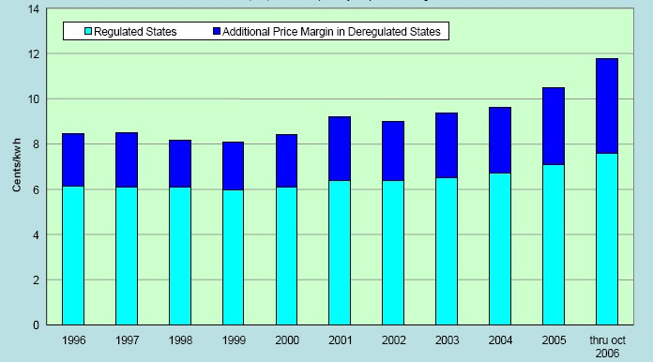
Source: Marilyn Showalter: Mapping Electricity Policy. 2007

Some deregulated states have introduced price caps in order to curb the effects of price rises. The price rises in deregulated states which are not protected by price caps show an even sharper contrast with those in states which retain a regulated structure.

Retail Price of Electricity in Rate-Regulated States and Deregulated States without Rate Caps in 2006 (cents /kWh)
All Customers | 2002 | 2003 | 2004 | 2005 | 2006 Jan-Oct. | Average Annual Growth 2002-06 | Average Annual Growth 2005-06
Rate-regulated states | 6.37 | 6.53 | 6.70 | 7.07 | 7.60 | 4.5% | 7.6%
Deregulated states without rate caps in 2006 | 9.01 | 9.39 | 9.61 | 10.50 | 11.79 | 7.0% | 12.3%
Difference between rate-regulated and deregulated states | 41% | 44% | 43% | 48% | 55%
Source: Rosen et al 2007.

The annual survey by NUS Consulting Group of electric rates paid by large customers served by major utilities also shows that in 2007, the highest rates are in states which have deregulated. NUS commented that “Considered in the past by many as a means of lowering electricity prices, the central promise of deregulation has yet to be fulfilled for many consumers……Retail deregulation is currently either stalled or ineffective in much of the country." A review by academics prepared for Virginia state in 2006 offers a general summary:
“The evidence suggests that, at least so far, no discernible benefit can be seen for customers in restructured states once the rate caps have expired. Increasingly the evidence is beginning to now suggest that prices for customers in restructured states may actually be increasing faster than for customers in states that did not restructure.”

Supporters of deregulation no longer claim that deregulation has reduced prices, only that it has not caused prices to increase. An analysis in June 2007 by the Brattle Group (which treats a larger set of states as ‘deregulated’) estimated that average electricity rates have increased 31% in both restructured and non-restructured states over the last decade and concluded that “Assuming costs increased similarly, it would appear restructuring did about as well as traditional regulation.”
Explanations for the effect of deregulation include the fact that neither consumers nor companies behave according to the assumptions of market supporters. Consumers in general have been reluctant to change suppliers, preferring the stability of regulated or integrated public systems, as opposed to the volatility of a market which may or may not yield efficiency and price gains. These preferences undermine the rationale for retail competition, as pointed out by an analysis of the California experience: “If consumers wish to be shielded from such volatility and wish to remain passive consumers of energy, the benefits of a competitive regime are reduced.”
Another consequence is that the old utilities retain nearly all the household customers, but no longer own their own power plants to supply them –and are thus vulnerable to the prices charged by the generating companies. And, as shown in California, the generating companies are able to exploit wholesale electricity markets, legally or illegally, rather than competing according to the expectations of market supporters: “During periods of peak demand the generation companies can charge prices far above the cost of production, in some cases 30 times the highest cost of production. The effect, experiments at Carnegie Mellon and George Mason Universities have shown, is to allow near monopoly prices even when there are competing electric-generating companies.”

One review of the US experience concludes that policy-makers should recognise the reality of this behaviour rather than making theoretical assumptions:
“Coordinated interaction and tacit collusion … are the results of structural characteristics and are an intrinsic part of the electricity supply industry…Appropriate public policy has to be shaped to fit these structural characteristics, and not be based on what works in other industries or on notions of what should work in theory.”
Evidence from elsewhere also confirms the USA experience with the impact of liberalisation. A recent study of power reforms in former communist countries and in Latin America concludes that: “The research findings suggest that neither unbundling nor introduction of a wholesale pool market on their own necessarily reduces the electric power price. In fact, contrary to expectations, there was a tendency for the price to rise.”

Economic impact: productivity, employment, growth and cohesion
There is still no clear evidence that liberalisation generates the efficiency gains or economic growth expected by its supporters. There may be an initial reduction in jobs leading to a one-off productivity gain, but with no evidence of any continuing or dynamic gains. (For a more detailed discussion of the evidence, see earlier critiques of EC evaluation reports ). Such one-off gains, with no continuing improvements, may represent only a boost to profits at the expense of employees, similar in nature to the impact of private equity buyouts, where a change of ownership leads to “management breaking implicit agreements and transferring wealth from employees to new owners”.

If there were major efficiency gains from liberalisation of these sectors, the benefits should be visible in overall European trends. But since the liberalisation directives started to be introduced in the late 1990s, the gap in productivity between the EU and the USA and Japan has widened (see chart).

The EC believes that the growth of the mobile telecom sector, in particular, can be attributed to liberalisation. But there is no basis for this assumption. Research on the development of mobile telecoms in the 1990s concluded that the development of digital technology and the licensing decisions of individual countries were the most important factors; that the introduction of competition had relatively little impact; and that incumbent telephone companies were not obstacles to development: “the effect from technological innovations has been much stronger than the effect of increasing the number of firms…No evidence of preemptive behaviour by incumbents could be found”. The EC also naively suggests that technological advances lead to greater competition: “ Competition also arises through innovation, such as internet telephony (Voice over Internet Protocol)” , whereas in practice the mobile telecom oligopolies have erected significant barriers to the use of this technology, which threatens their own revenues.

Productivity growth in the US, EU-15 and Japan, 1995-2005
Source: EC: Fourth Report On Economic And Social Cohesion May 2007

The evidence also suggests that the change in employment in the liberalised sectors is negative overall, with particularly large job losses in the energy sectors, only partly offset by employment growth in telecoms. In new member states, the employment trend is negative even in telecoms. The EC argues that jobs are created elsewhere in the economy, but this argument depends entirely on the impact of reducing prices for industry as a whole, and, as noted above, there is no clear evidence of this effect on prices. (For a more detailed discussion of the evidence, see earlier critiques of EC evaluation reports ).

Employment trends in electricity, gas and water in EU 1996-2003
Source: EC Evaluation report 2006, calculated from Groningen Database.

One way of evaluating the impact of liberalisation is to compare it with the impact of another form of state intervention in industry, namely public investment. This is not only done by nation states: the EU itself also actively intervenes through the medium of public investment, through the structural and cohesion funds. While the contribution of liberalisation to growth, efficiency and economic cohesion remains uncertain, the contribution of public investment in infrastructure to economic development, growth and efficiency is well-established.

There is also evidence that it stimulates further gains through competition between sectors. The growth of total factor productivity in the USA from the 1920s to the 1970s was derived principally from public investment in electricity and roads networks, but the investment in road systems was also associated with a significant increase in productivity of the railway systems, because of competition between the different modes of transport. This role of competition in multiplying efficiency gains in one sector may have more impact than the attempt by the EU liberalisation directives to force competition within each sector. Productivity gains arising from public investment or technology in one sector may be generalised through competition between different modes e.g. between road and rail; post, fixed and mobile telecom and internet; and electricity and gas (and district heating).

Public investment in infrastructure has an especially positive impact on growth in less developed regions and countries. For example, public capital investment has had a demonstrably positive impact on industrial productivity in Italian regions, especially in the south, and on the productivity of the manufacturing sector in Greece.
This positive developmental gain is clear in the impact of EU cohesion funds on growth, employment and productivity. These funds produce substantial positive gains in terms of economic growth and employment in the new member states. This is not just the result of increased demand arising from the spending: about half of the benefits in terms of GDP and employment are the result of supply-side effects through improved productivity in the economy as a whole: “Supply side improvements account for around half of the gain.” These gains for new member states are almost neutral NMS at little short-term cost to the member states which contribute to the financing of these funds: “For the EU-27, the overall effects are … predicted to be small and negative over most of the programming period, but positive in later years, indicating that cohesion policy adds to the growth of the EU as a whole in the long term, as well as assisting convergence.”

Effect of cohesion policy spending 2007-2015 on GDP
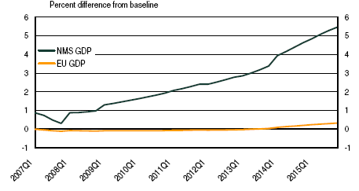
Source: EC: Fourth Report On Economic And Social Cohesion 2007 p. 97 Chart 2.2
By contrast, the cohesion effects of the liberalisation directives appear to be regressive in terms of efficiency and employment. Productivity trends in energy have been rising in EU15, but level in NMS (in other sectors trends are similar in both sets of states - upwards in communications, level in inland transport). Employment in communications and inland transport grew in the EU15 between 1996 and 2003, but fell in NMS: in electricity and gas employment fell in both sets of states.

Impact of policies on employment and productivity 1996-2003: EU15 and NMS
+ positive impact; = neutral ; - negative impact
Policy | Level | Employment |  | Productivity
 |  | EU15 | NMS | EU15 | NMS
Energy liberalisation | Sector | - | - | + | =
Communications liberalisation | Sector | + | - | + | +
Inland transport liberalisation | Sector | + | - | = | =
Cohesion policy | Economy | = | + | = | +
Source: Calculated from EC Horizontal Evaluation 2006; Fourth report on Economic and Social Cohesion 2007

Conclusions
Firstly, the debate on policies in these sectors needs to be guided by reference to a much wider range of issues than simply the extension of the internal market. The EU treaties themselves include a far wider range of objectives than the internal market, and the evaluation recognises the relevance of the impact on employment and cohesion, but the EC sees liberalisation as synonymous with improvement. If the EC continues to produce evaluation reports in the same way as for 2004, 2005 and 2006, it is certain that they will conclude for 2007, 2008, 2009 and all future years that current policies are correct and the only improvements necessary are to increase and accelerate the extent of liberalisation.
The proposed revision to the treaty should help force a re-appraisal of this position. The proposed new article 3 includes a commitment to work for: “a highly competitive social market economy, aiming at full employment and social progress, and a high level of protection and improvement of the quality of the environment.”, and strengthens the commitment to “take care that services [of general economic interest] operate on the basis of principles and conditions, particularly economic and financial conditions, which enable them to fulfil their missions” . Social, employment, environmental and public service objectives are not subordinate to the maximisation of the internal market.

Secondly, democratic institutions and public debate should be central to evaluation and review of the liberalisation policies. There is evidence that in Europe, as in the USA, citizens mistrust the behaviour of private companies and believe that they are being exploited under retail competition, and may prefer the certainty provided by vertically integrated public monopolies in these services. This choice has to be made through democratic political institutions, as in the USA, not through market mechanisms. Governments, public authorities, stakeholders and the public itself need to be actively involved in a democratic assessment of policies. And this debate needs to be informed by data and analysis from a range of independent analysts, not a single technical paper produced by the EC itself.

Thirdly, the EC needs to follow the public in making a more hardheaded assessment of how companies actually behave. At present, their evaluations are based on a naïve ideal of competitive behaviour by companies which bears little relations to the oligopolistic and opportunistic behaviour actually observed.

Notes

The “Horizontal Evaluation of the Performance of Network Industries” is published annually. The latest report is: Evaluation of the Performance of Network Industries Providing Services of General Economic Interest 2006 Report. Commission Staff Working Document SEC(2007) 1024. http://ec.europa.eu/economy_finance/publications/european_economy/2007/ee0107_en.htm (the definitive version will be published as European Economy n° 1/2007). A critique of some technical aspects of the 2006 report is attached as an annexe to this paper, which also references PSIRU critiques of earlier evaluation reports.
European Commission. A Methodological Note for the Horizontal Evaluation of Services of General Economic Interest. Brussels, 18.6.2002. COM(2002) 331 final (section 3.1.(d), p.5) http://europa.eu.int/comm/economy_finance/publications/structural_policies/2002/com_2002_331_en.pdf )
Electricity Market Reform in the European Union: Review of Progress toward Liberalization & Integration. Tooraj Jamasb and Michael Pollitt University of Cambridge March 2005 http://web.mit.edu/ceepr/www/2005-003.pdf
APPA: Power Supply Procurement in Retail Choice States June 2007 http://www.appanet.org/files/PDFs/powersupplyprocurement.pdf
New York Times September 4, 2007. More than a decade after the drive began to convert electricity from a regulated industry into a competitive one, many states are rolling back their initiatives or returning money to individuals and businesses. By David Cay Johnston
Nancy Brockway, Delaware’s Electricity Future: :Re-Regulation Options and Impacts May 2007 http://www.nbrockway.com/del-electric-future-final.pdf ).
The Maryland Gazette July 25, 2007 Warnings ignored a decade ago
USA TODAY August 10, 2007: Shocking prices follow deregulation; States that dropped price caps watch and worry as rates soar. Paul Davidson.
Nancy Brockway, Delaware’s Electricity Future: :Re-Regulation Options and Impacts May 2007 http://www.nbrockway.com/del-electric-future-final.pdf ).
USA TODAY August 10, 2007: Shocking prices follow deregulation; States that dropped price caps watch and worry as rates soar. Paul Davidson.
USA TODAY August 10, 2007: Shocking prices follow deregulation; States that dropped price caps watch and worry as rates soar. Paul Davidson.
New York Times September 4, 2007. More than a decade after the drive began to convert electricity from a regulated industry into a competitive one, many states are rolling back their initiatives or returning money to individuals and businesses. By David Cay Johnston
Peter Van Doren and Jerry Taylor. Rethinking Electricity Restructuring. Cato Institute Policy Analysis No. 530 November 30, 2004 http://www.cato.org/pubs/pas/html/pa530/pa530index.html
Electricity Market Reform in the European Union: Review of Progress toward Liberalization & Integration. Tooraj Jamash and Michael Pollitt University of Cambridge March 2005 http://web.mit.edu/ceepr/www/2005-003.pdf
Public Utilities Fortnightly August, 2007 Asian Electric Competition; Custom Tailored For Success; Taking the anti-FERC approach to the grid. By Vikram Janardhan, Ajit Kulkarni, Ph. D., Narottam Aul, And Ng Meng Poh.
Market Opening in Network Industries. By Copenhagen Economics. September 2005. Published in 3 parts - Part 1: Final report http://europa.eu.int/comm/internal_market/economic-reports/docs/2005/part_i_final_report_en.pdf ; Part II: Sectoral Analyses. http://europa.eu.int/comm/internal_market/economic-reports/docs/2005/part_ii_sectoral_analyses_en.pdf ; and an Explanatory Note to Part II of the Final Report. http://europa.eu.int/comm/internal_market/economic-reports/docs/2005/explanatory_note_to_part_ii_en.pdf
C.V. Fiorio, M. Florio, S. Salini and P. Ferrari. Consumers’ Attitudes on Services of General Interest in the EU: Accessibility, Price and Quality 2000-2004 Nota Di Lavoro 2.2007 JANUARY 2007 http://www.feem.it/NR/rdonlyres/C76E5019-9722-4B8D-81B7-1BA20D0C031E/2216/207.pdf
Evaluation of the Performance of Network Industries Providing Services of General Economic Interest 2006 Report. Commission Staff Working Document SEC(2007) 1024. p. 87 http://ec.europa.eu/economy_finance/publications/european_economy/2007/ee0107_en.htm
Evaluation of the Performance of Network Industries Providing Services of General Economic Interest 2006 Report. Commission Staff Working Document SEC(2007) 1024. http://ec.europa.eu/economy_finance/publications/european_economy/2007/ee0107_en.htm
Marilyn Showalter: Mapping Electricity Policy. Power in the Public Interest. 26 Feb 2007 www.ppinet.org
Richard Rosen, Marjorie Kelly and John Stutz: A Failed Experiment: Why Retail Competition Did Not Work and Could Not Work p.3 Tellus Institute March 2007 http://www.tellus.org/publications/A_Failed_Experiment.pdf ;
Platts Electric Utility Week June 11, 2007 Survey on utility rates shows very similar movement in restructured, traditional states
Rose p. 4. Rose, Kenneth and Karl Meeusen, 2006 Performance Review of Electric Power Markets: Review Conducted for the Virginia State Corporation Commission, August 27, 2006 http://www.scc.virginia.gov/caseinfo/reports/2006_rose_1.pdf .
"Restructuring Revisited: What we can learn from retail-rate increases in restructured and non-restructured states," by Gregory Basheda, Johannes P. Pfeifenberger, and Adam C. Schumacher. Brattle Group. Public Utilities Fortnightly, June 2007.
Some econometric studies have concluded that deregulation has caused prices to be lower than they would otherwise have been, and suggest that price rises should rather be attributed to the impact of the costs of different mixes of fuels, e.g. a study of the impact of ‘Coordinated Electricity Markets’ but the data used is limited to small subsets of both regulated and deregulated states that cover only 7% of the USA. Scott M. Harvey, Bruce M. McConihe and Susan L. Pope Analysis of the Impact of Coordinated Electricity Markets on Consumer Electricity Charges. Center for Research in Regulated Industries Rutgers University 20th Annual Western Conference Monterey, California November 20, 2006 (Revised June 18, 2007) LECG http://www.lecg.com/website/home.nsf/OpenPage/Energy-ResearchPapersTestimony/$FILE/AnalysisImpactCoordinatedElectricityMkts.pdf; and Restructuring The U.S. Electric Power Sector: A Review of the LECG Study John Kwoka Northeastern University April 2007 http://www.appanet.org/files/PDFs/KwokaLECGReview.pdf
The California Electricity Crisis: Causes and Policy Options Christopher Weare January 2003, 140 pp. ISBN 1-58213-064-7 http://www.ppic.org/content/pubs/report/R_103CWR.pdf
New York Times September 4, 2007. More than a decade after the drive began to convert electricity from a regulated industry into a competitive one, many states are rolling back their initiatives or returning money to individuals and businesses. By David Cay Johnston
Rose p. 4. Rose, Kenneth and Karl Meeusen, 2006 Performance Review of Electric Power Markets: Review Conducted for the Virginia State Corporation Commission, August 27, 2006 http://www.scc.virginia.gov/caseinfo/reports/2006_rose_1.pdf
Hiroaki Nagayama Effects of regulatory reforms in the electricity supply industry on electricity prices in developing countries Energy Policy Volume 35, Issue 6, June 2007, Pages 3440-3462 doi:10.1016/j.enpol.2006.12.018
Hall D. Evaluating network services in Europe PSIRU March 2006 http://www.psiru.org/reports/2006-03-EU-EPNIcrit.doc; Hall D. Evaluating the impact of liberalisation on public services PSIRU March 2005 http://www.psiru.org/reports/2005-03-EU-U-horizeval.doc
Amess K. and Wright M. 2007 The Wage And Employment Effects Of Leveraged Buyouts In The UK. Forthcoming: International Journal of Economics and Business 2007. For a discussion of the employment impact of private equity, see David Hall: Methodological issues in estimating the impact of private equity buyouts on employment PSIRU. May 2007 http://www.psiru.org/reports/2007-05-PE-emp.doc
Harald Gruber and Frank Verboven: The Diffusion of Mobile Telecommunications Services in the European Union” CEPR Paper No. 2054 1999 European Economic Review, 2001, vol. 45, issue 3, pages 577-588 http://www.sciencedirect.com/science/article/B6V64-42C07X4-B/2/82e3de3ec8852efaff4bdc07c6aba7e4
P.29
EC: Fourth Report On Economic And Social Cohesion May 2007 http://ec.europa.eu/regional_policy/sources/docoffic/official/reports/cohesion4/pdf/4cr_en.pdf
Hall D. Evaluating network services in Europe PSIRU March 2006 http://www.psiru.org/reports/2006-03-EU-EPNIcrit.doc; Hall D. Evaluating the impact of liberalisation on public services PSIRU March 2005 http://www.psiru.org/reports/2005-03-EU-U-horizeval.doc
For a recent overview of literature see Ward Romp and Jakob de Haan. Public Capital and Economic Growth: A Critical Survey. Perspektiven der Wirtschaftspolitik 2007 8 (Special Issue): 6–52
Alexander J. Field The origins of US total factor productivity growth in the golden age. Cliometrica (2007) 1:63–90
Public Capital and Total Factor Productivity: New Evidence from the Italian Regions, 1970–98 SERGIO DESTEFANIS* and VANIA SENA† Regional Studies, Vol. 39.5, pp. 603–617, July 2005 http://dx.doi.org/10.1080/00343400500151863
E.C. Mamatzakis. EU infrastructure investment and productivity in Greek manufacturing. Journal of Policy Modeling Volume 29, Issue 2, March-April 2007, Pages 335-344
EC: Fourth Report On Economic And Social Cohesion May 2007 p. 96 Table 2.3b http://ec.europa.eu/regional_policy/sources/docoffic/official/reports/cohesion4/pdf/4cr_en.pdf
EC: Fourth Report On Economic And Social Cohesion May 2007 p. 96 Table 2.3b http://ec.europa.eu/regional_policy/sources/docoffic/official/reports/cohesion4/pdf/4cr_en.pdf
EC: Fourth Report On Economic And Social Cohesion May 2007 p. 96 Table 2.3b http://ec.europa.eu/regional_policy/sources/docoffic/official/reports/cohesion4/pdf/4cr_en.pdf
As pointed out by Pierre Bauby at the Economic and Social Committee in September 2007, the EC is so obsessed with this issue that the opening sentence of the 2006 evaluation misrepresents the EU treaty be claiming that Article 16 of the treaty requires the safeguarding of services of general economic interest “while respecting the principle of undistorted competition in the internal market” – whereas article 16 in fact makes no reference to the internal market.
Draft Treaty amending the Treaty on European Union and the Treaty establishing the European Community. CIG 1/07. 23 July 2007. p.5, 49 http://www.consilium.europa.eu/uedocs/cmsUpload/cg00001.en07.pdf )

