**MAER-Net Colloquium**

Greenwich University, School of Business

October 11-12, 2019

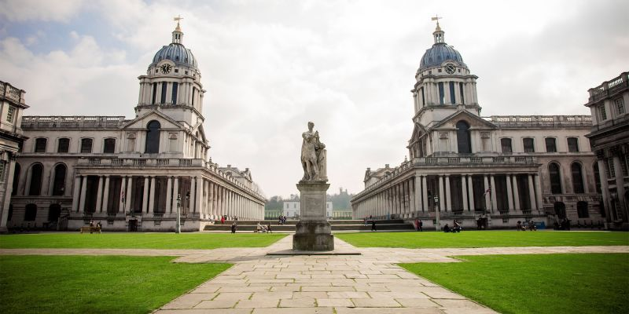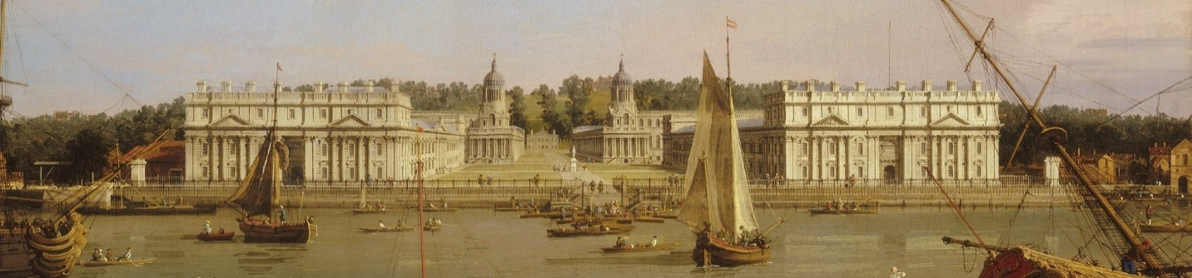

Visit Colloquium website to register (no fee) and for further information at: <https://www.gre.ac.uk/events/current-events/faculty-of-business/2019-MAER-Net-Colloquium-d11-10-2019-a1642846>

|  |  |
| --- | --- |
| **Thursday, Oct 10, 2019 {Participants Arrive}** | |
| 16:00 – 17:45 | **Optional tour of the Greenwich Campus**  *The tour will start outside of Hamilton House* |
| 18:00 – late | **Optional welcome drinks at Trafalgar Tavern** |
| **Friday, Oct 11, 2019** | |
| **{Keynote speeches: 35 minutes; Papers: 20 min; Discussions: 5 min}** | |
| 08:00 - 08:45 | **Registration at Hamilton House Reception** |
| 08:45 - 09:00 | **Welcome Address** |
| 09:00 - 10:30 | **Plenary Session I:** (Chair: Denise Hawkes)  **Keynote: Thinking outside the box: its challenges and achievements when synthesising economics research**  **Sandy Oliver** UCL, Institute of Education, London, UK  Individual discount rates: Experimental evidence  **Tomas Havranek** Charles University & Czech National Bank  Cognitive training does not work at all  **Fernand Gobert** University of Liverpool, UK |
| 10:30 - 10:45 | **Break** |
| 10:45 - 12:30 | **Parallel Session Ia: Labour Economics** (Chair: Robert Gal)  Is profit sharing productive?  **Patrice Laroche** Université de Lorraine, France  Minimum wages and poverty  **Georgios Giotis** University of Ioanniana, Greece  Gender wage gap in China  **Xinxin Ma** University of Toyama, Japan  The elasticity of substitution between capital and labour  **Patrick Zwerschke** Technical University, Dresden, Germany |
| 10:45 - 12:30 | **Parallel Session Ib: Finance** (Chair: Evzen Kocenda)  Forward rate unbiasedness puzzle  **Diana Zigraiova** Charles University, Czech Republic  Commodity futures hedge rates  **Devmali Perera** Canterbury University, New Zealand  Relationship banking and firm performance  **Louis Raes** Tilburg University, The Netherlands  Crime and punishment of listed companies  **Evžen Kočenda** Charles University, Czech Republic |
| 12:30 - 13:30 | **Lunch** |

|  |  |
| --- | --- |
| **Friday, October 11 - Continued** | |
| 13:30 - 15:10 | **Colloquium: Replication ‘Crisis’ or Credibility Revolution** (Chair: Chris Doucouliagos)  Why we need more multi-lab or multi-condition studies rather than high-powered studies  **Marcel van Assen** Tilburg University, The Netherlands  Correcting for publication bias in a meta-analysis with p-uniform*  **Robbie C.M. van Aert** Tilburg University, The Netherlands  When and why to replicate: As easy as 1, 2, 3?  **Sarahanne Field** University of Groningen, The Netherlands  Making meta-analysis credible again: Median retrospective power  **Tom Stanley** Deakin University, Australia |
| 15:10 - 15:30 | **Break** |
| 15:30 - 17:10 | **Parallel Session IIa: Law, Taxes, & Intellectual Property Protection** (Chair: Satoshi Mizobata)  Explaining differences in judicial efficiency  **Francesco Aiello** University of Calabria, Italy  Are the results of tax incentives so unambiguous?  **Florence Blandinieres** ZEW, Germany  Does intellectual property rights protection spur innovation and diffusion?  **Hoang M. Luong** Greenwich University, UK  Is intellectual property rights protection good for growth and productivity?  **Mehmet Ugur**Greenwich University, UK |
| 15:30 - 17:10 | **Parallel Session IIb: Methods** (Chair: Marcel van Assen)  Statistical properties of multiple FAT-PET-MRA  **Pedro Bom** University of Deusto, Spain  The meta-plot: A descriptive tool for meta-analysis  **Hilde Augusteijn** Tilburg University, The Netherlands  Sample overlap in marketing  **Heiko Rachinger** Universitat de les Illes Balears, Spain  Assessing quality and susceptibility to bias  **Anande Semwenda** UCL, Institute of Education, London, UK |
| 19:00 - 21:00 | **Dinner at Bills Greenwich**  *You are only able to attend this dinner if you have registered and provided your menu choices to the Business School events team by Wednesday 9 October at the latest.* |

|  |  |
| --- | --- |
| **Saturday, October 12** | |
| **8:30-9:00** | **MAER-Net Open Forum** |
| 9:00 – 10:30 | **Plenary Session III:** (Chair: Tomas Havranek)  **Keynote: Identification of and correction for publication bias**  **Isaiah Andrews** Harvard University, US  Human rights and aid allocations  **Martin Paldam** University of Aarhus, Denmark  Financial development and income inequality  **Nora Freudenberg** Zeppelin University, Germany |
| 10:30 - 10:45 | **Break** |
| 10:45 - 12:45 | **Parallel Session IIIa: FDI, the Euro and Losses** (Chair: Mehmet Ugur)  Synchronisation and the Euro  **Jarko Fidrmuc** Zeppelin University, Germany  Does investor protection increase FDI?  **Ichiro Iwasaki** Hitotsubashi University, Japan  Motives to invest in Africa  **Amar Anwar** Cape Breton University, Canada  Does the EMU promote FDI?  **Biljana Avramovska** University of Staffordshire, UK  Meta-analysis of loss aversion  **Taisuke Imai** LMU Munich, Germany |
| 10:45 - 12:45 | **Parallel Session IIIb: Government, Politics and the Environment** (Chair: Joanna Tyrowicz)  On the impact of environmental events  **Gunther Capelle Blancard** Université de Paris 1 Sorbonne, France  Does inter-municipal cooperation really reduce delivery costs?  **Marianna Sebő** Universitat de Barcelona, Spain  Social impacts on the adoption of organic food  **Quang Nguyen** University of Strasbourg, France  Which get-out-the-vote initiatives genuinely work?  **Tom Rutter** London School of Economics, UK  Does the ‘Left’ spend more?  **Georgios Magkonis** Portsmouth Business School, UK |
| 12:45 - 13:45 | **Lunch** |

|  |  |
| --- | --- |
| **Saturday, October 12 - Continued** | |
| 13:45 - 15:45 | **Plenary Session IV: Symposium on Meta-Research** (Chair: Tom Stanley)  Publication bias and editorial statements on negative findings  **Abel Brodeur** University of Ottawa, Canada  Publication bias and academic age  **Katarina Zigova** University of Konstanz, Germany  The (non-)significance of reporting errors in economics  **Stephan B. Bruns** University of Goettingen, Germany  Glory without power: A new ranking of journals  **Chris Doucouliagos**, Deakin University, Australia  Methods matter: p-hacking and causal inference in economics  **Nikolai Cook** University of Ottawa, Canada |
| 15:45 - 16:00 | **Break** |
| 16:00 – 18:00 | **Plenary Session V:** (Chair: Dominika Kolcunova)  Social capital and health  **Robert Reed** University of Canterbury, New Zealand  Cross-cultural apology studies  **Puyu Ning** Hungarian Academy of Sciences  Life after the viva: Assessing economic impact of the doctoral degrees  **Aleksandra Griazina** UCL Institute of Education, London, UK |